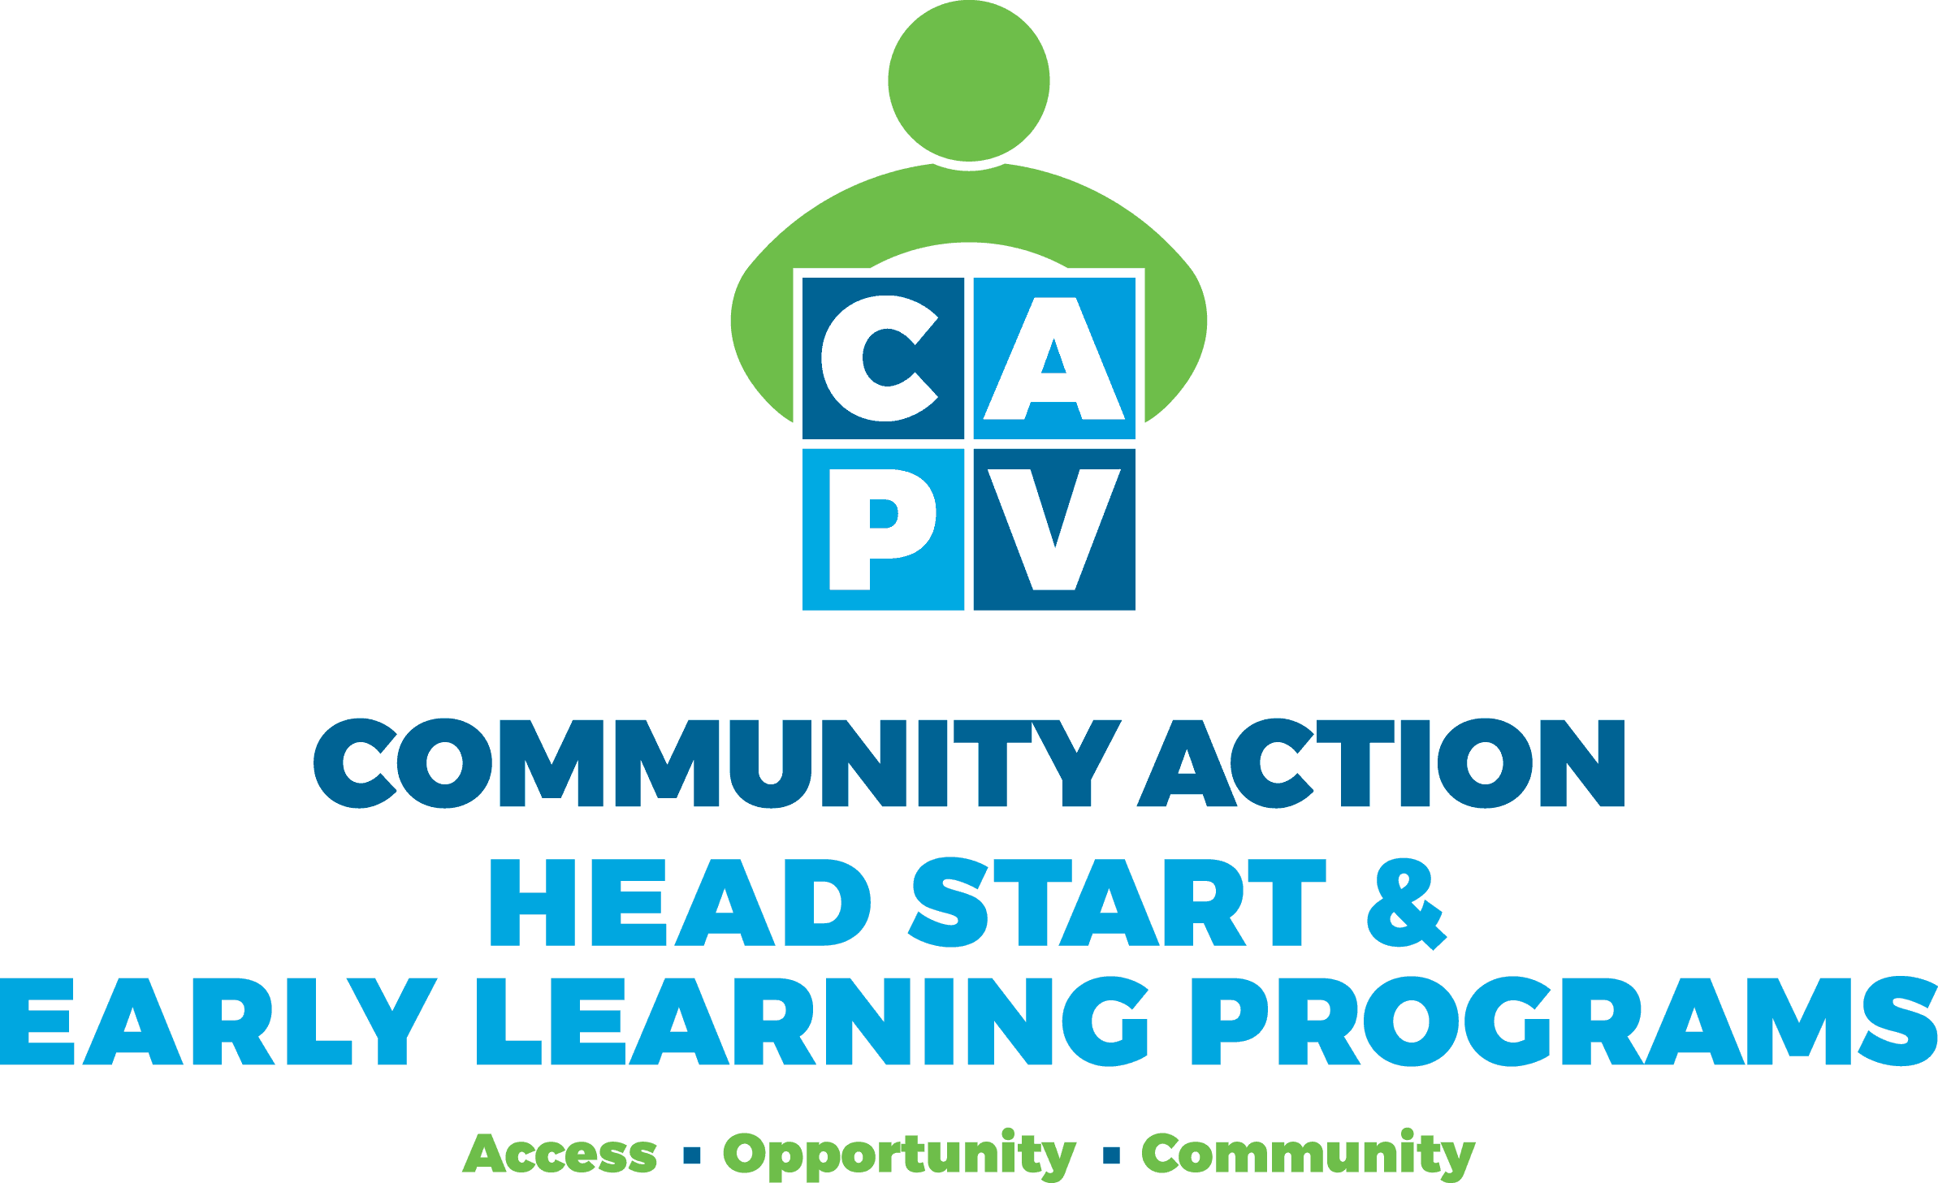

Referral Form

Date Sent: Click or tap to enter a date.

Child Name: Click or tap here to enter text. DOB: Click or tap to enter a date.

Parent Name: Click or tap here to enter text. DOB: Click or tap to enter a date.

Phone Number: Click or tap here to enter text. Alternate Phone Number: Click or tap here to enter text.

Address: Click or tap here to enter text.

### If pregnant and applying for EHS services, expected due date: Click or tap to enter a date.

**Reason for Referral:**

Click or tap here to enter text.

Referring Agency: Click or tap here to enter text. Referring Staff Name: Click or tap here to enter text.

Title: Click or tap here to enter text. Phone Number: Click or tap here to enter text.

Release:

**I consent to allow Head Start & Early Learning Programs (HS & ELP) to contact me regarding this referral. This authorization expires in one year. I understand that a photocopy, scan, or fax of this authorization shall have equal validity with the original.**

**Parent/Guardian Signature __________________________________________________ Date _________________**

Please call 413-387-1250, email form to [hselpenrollment@communityaction.us](mailto:hselpenrollment@communityaction.us) or fax to 413-387-1224